Joseph McCoy

Homework 2 – My First Android App

CIS 490

Screen 1: Screen 2:

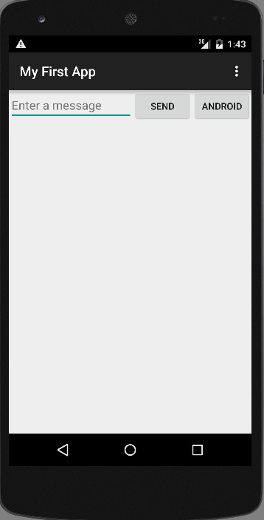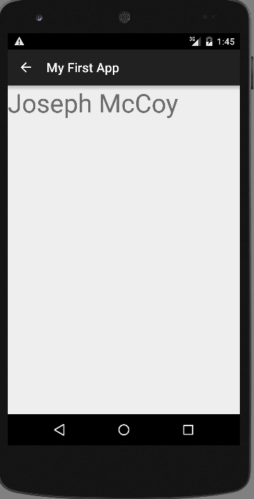

Screen 3:

